EXPERIMENT – 5

DESIGN AND SIMULATION OF UJT RELAXATION OSCILLATOR USING LTSPICE

OBJECTIVES

- Analysis of UJT Relaxation Oscillator.
- Determine Bandwidth
- Determine Duty Cycle

EXPERIMENT – 5.1

FREQUENCY ANALYSIS OF UJT RELAXATION OSCILLATOR USING LTSPICE

After completion of this experiment, students will be able to:

- Understand the construction and operating principle of a Unijunction Transistor (UJT).
- Explain the working of a UJT Relaxation Oscillator.
- Verify the generation of oscillations using a UJT-based oscillator circuit.
- Observe the charging and discharging characteristics of the timing capacitor.
- Measure the oscillation frequency and compare it with the theoretical value.
- Analyze the effect of resistance and capacitance values on the oscillation frequency.
- Identify and interpret the sawtooth waveform and trigger pulse waveform generated by the circuit.
- Determine the role of the intrinsic stand-off ratio (η)(\eta)(η) in oscillator operation.
- Plot and analyze the output waveforms using a CRO/oscilloscope or simulation tool.
- Apply UJT oscillators in timing, triggering, pulse generation, and sweep generation applications.

Aim

To verify the operation of a UJT Relaxation Oscillator.

THEORY

The UJT relaxation oscillator generates non-sinusoidal oscillations. Operation:
  - Capacitor charges exponentially.
  - UJT triggers at peak voltage.
  - Capacitor discharges rapidly.
  - Cycle repeats continuously.

DESIGN FORMULA:

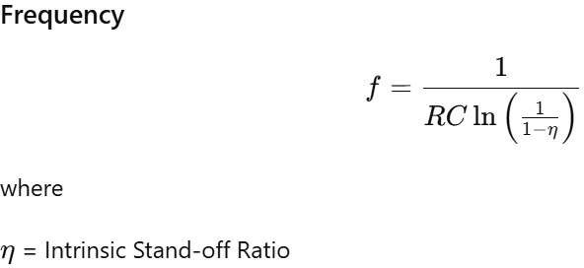

PROCEDURE

- Draw UJT oscillator in LTSpice.
- Configure RC network.
- Run transient analysis.
- Observe sawtooth waveform.
- Measure oscillation frequency.

Circuit diagram:

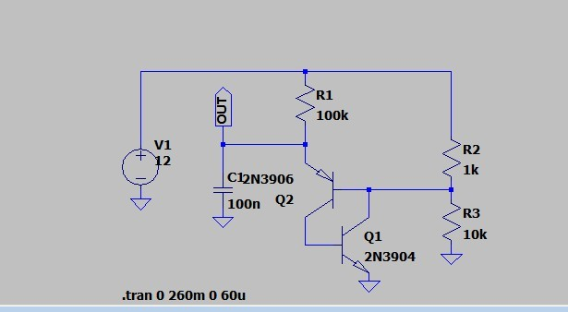

Procedure:
  - Connections are made as shown in the circuit diagram.
  - The DC power supply is switched ON.
  - The output waveform is displayed on the CRO.
  - The peak-to-peak Amplitude and time period of the sine wave is noted.
  - The graph of output waveform is drawn.

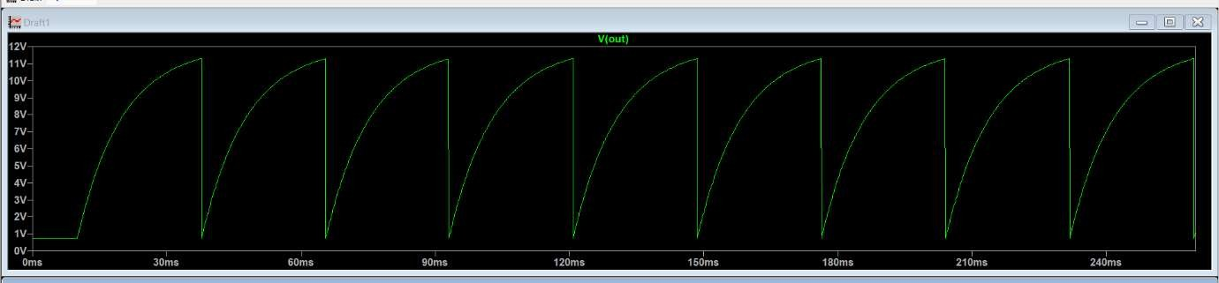
Model Graph:

OBSERVATION TABLE

Waveform | Observation
Amplitude | 11.4V
Time period | 38.06ms
Frequency | 26.27 Hz

Result:
UJT Relaxation Oscillator using LTSpice was completed and output obtained.

EXPERIMENT – 5.2

BANDWIDTH ANALYSIS OF UJT RELAXATION OSCILLATOR USING LTSPICE

After completion of this experiment, students will be able to:

- Understand the operating principle of a UJT Relaxation Oscillator and its frequency-determining mechanism.
- Simulate a UJT Relaxation Oscillator using LTSpice software.
- Analyze the charging and discharging behavior of the timing capacitor in the oscillator circuit.
- Measure the oscillation frequency from the simulated output waveform.
- Compare theoretical and simulated frequency values of the oscillator.
- Investigate the effect of varying resistance (R)(R)(R) and capacitance (C)(C)(C) values on the oscillation frequency.
- Observe and interpret the generated sawtooth and pulse waveforms using LTSpice.
- Plot and analyze the relationship between frequency and RC time constant.
- Apply LTSpice simulation tools for frequency analysis and performance evaluation of relaxation oscillators.

Aim

To verify frequency variation with RC values.

Circuit diagram:
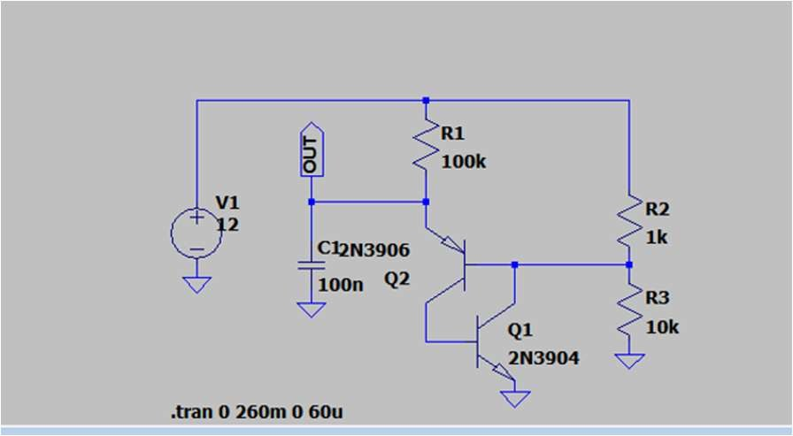

Procedure:
  - Connections are made as shown in the circuit diagram.
  - The DC power supply is switched ON.
  - The output waveform is displayed on the CRO.
  - The peak-to-peak Amplitude and time period of the sine wave is noted.
  - The graph of output waveform is drawn.

Model Graph:

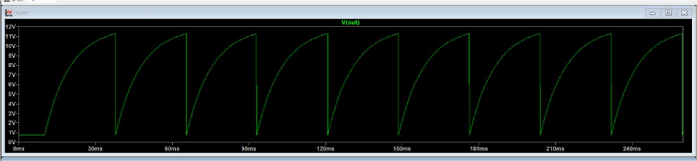

OBSERVATION TABLE

Waveform | Observation
Amplitude | 11.4V
Time period | 38.06ms
Frequency | 26.27 Hz
Bandwidth | 11.16 Hz

Result:
Thus the bandwidth of UJT Relaxation Oscillator using LTSpice was completed and output obtained.

EXPERIMENT – 5.3

WAVEFORM ANALYSIS OF UJT RELAXATION OSCILLATOR WITH DUTY CYCLE USING LTSPICE

After completion of this experiment, students will be able to:

- Understand the operating principle of a UJT Relaxation Oscillator and its frequency-determining mechanism.
- Simulate a UJT Relaxation Oscillator using LTSpice software.
- Analyze the charging and discharging behavior of the timing capacitor in the oscillator circuit.
- Measure the oscillation frequency from the simulated output waveform.
- Compare theoretical and simulated frequency values of the oscillator.
- Investigate the effect of varying resistance (R)(R)(R) and capacitance (C)(C)(C) values on the oscillation frequency.
- Observe and interpret the generated sawtooth and pulse waveforms using LTSpice.
- Plot and analyze the relationship between frequency and RC time constant.
- Apply LTSpice simulation tools for frequency analysis and performance evaluation of relaxation oscillators.

Duty Cycle
  - Ratio of pulse width to total period:
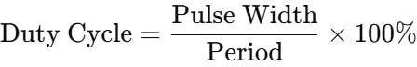

Circuit diagram:
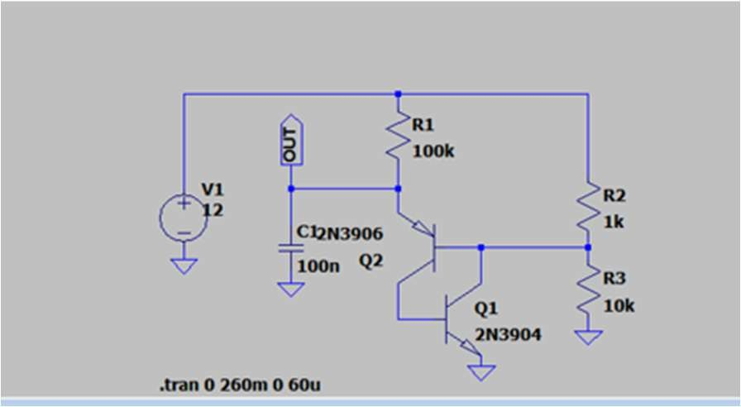

Procedure:
- Connections are made as shown in the circuit diagram.
- The DC power supply is switched ON.
- The output waveform is displayed on the CRO.
- The peak-to-peak Amplitude and time period of the sine wave is noted.
- The graph of output waveform is drawn.

Model Graph:

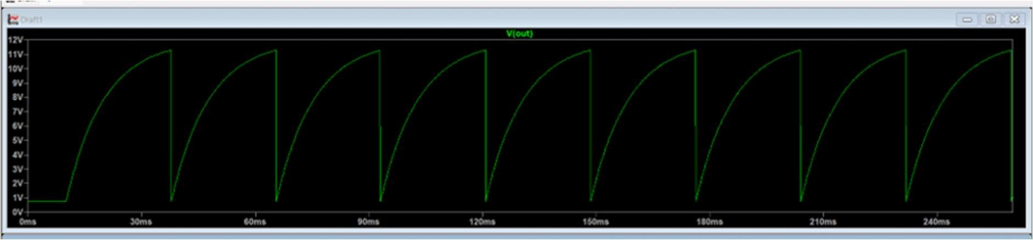

OBSERVATION TABLE

Waveform | THEORITICAL | PRACTICAL
Pulse width | 28 | 27.69
period | 39 | 38.06
Duty Cycle | 73 | 72.75

Result:
UJT Relaxation Oscillator using LTSpice was completed and output obtained.

